**ATS Process - New hire – Network account creation**

**Task names: AD & Email Account Setup for New Hire**

|  |  |
| --- | --- |
| **Autor: Eduardo Osuna** | **Account: Trinity** |
| **Version: 1.0** | **Document type: Knowledge** |
| **Creation Date: 03/28/2021** | **Last Modification:** |
| **Owner: Eduardo Osuna** | **Last Modification made by:** |

**AD AND EMAIL**

ARS path: Quest One ActiveRoles> Configuration > Managed Units> _Trinity > Service Desk > TRN Provision w/ Mailbox > Users or TRN Provision w/o Mailbox > Users.

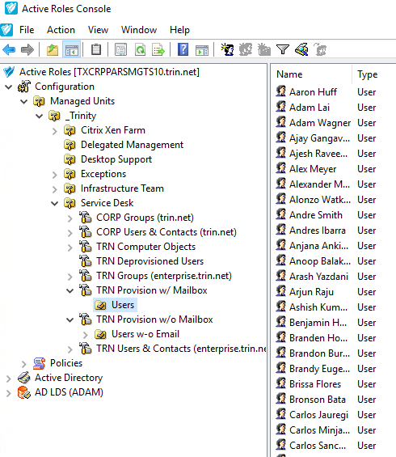

**NO EMAIL**

ARS path: Quest One ActiveRoles> Configuration > Managed Units> _Trinity > Service Desk > TRN Provision w/o Mailbox > Users

**Staging Steps**

1. Open Quest One ActiveRoles Console, follow the path specified above 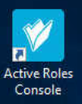
2. Click on the icon with one face to create new user in the specified path (You may also right click inside folder and click New> User) 
3. Copy and paste user's information as specified in New Hire form 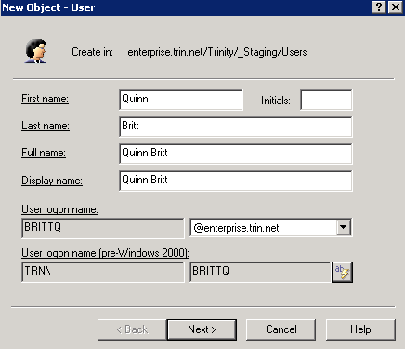
4. Click on AB bolt button to generate username and click next. 
5. Ensure there are no duplicates in the database. This can be done by checking the username (user´s name) in AD specially if it comes up with a number.
6. Create Password (First name initial uppercase + Last name initial lowercase + Employee number + If needed add zeros to comply with password length *8 characters minimum) Make sure 'User must change password at next logon' is checked. Click next. 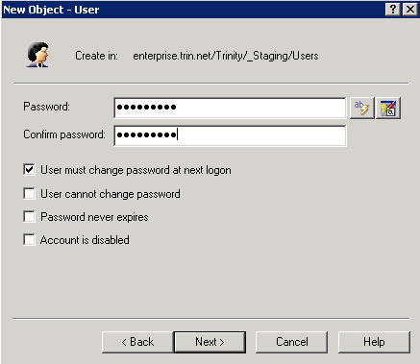
7. Click and edit the following fields depending on the new hire form: 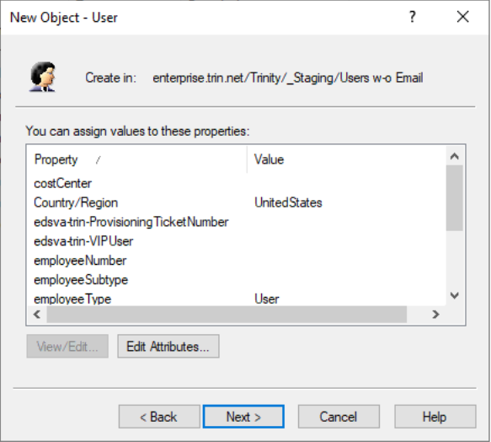
   1. Country/Region > United States (Even for Canada) or Mexico
   2. employeeNumber > paste employee number from new hire form
      1. If user is contractor and does not have an employee number, assign one from contractor database.
   3. Enter Cost center with the configuration Physical plant number + Department number (Plant 2099 + Department 6120 > Cost Center: 20996120
   4. If user is VIP, click on trnVIPUser and type true, if not, leave blank
   5. employeeSubtype > Leave blank
   6. employeeType > Select User for FTEs and Contractor for all others
   7. IP Phone number > Leave as is
   8. Manager > Double click on the field to be populated and then on the three dotted button, search for manager with e-mail. Click OK. (Make sure DN syntax appears in Value [see below])

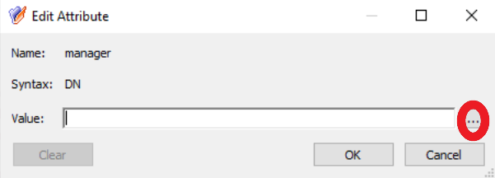

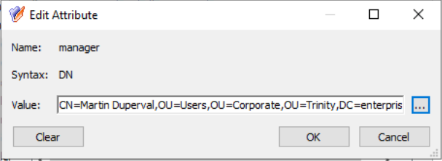

* 1. Office Location > Type office number from new hire form and select correct option from drop down menu. (shortcut: Type P# and press the down arrow key [this is useful in most scroll down cases])
  2. trnProvisionTicketNbr > Copy/Paste service request number from TSM form.
  3. trnVIPUser> Leave blank
  4. Click on the field labeled "o", click Add and select company number (CO#) from drop down menu, click ok on all windows.
  5. Click Next, click Next, check box to “display the object properties when this wizard closes”, click Finish.

1. From AD properties:
   1. General tab > Verify user's information is correct.
   2. Address tab > Fill in physical address from new hire request form, city, state code only (unless from Mexico) and zip code. If address was not specified in TSM, search E-plants. 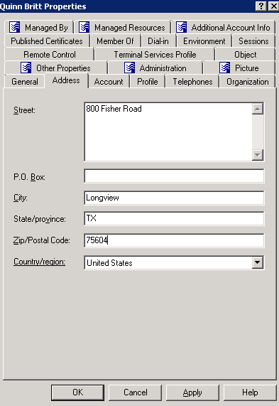
   3. Account tab > Set expiration date based on type of employee:
      1. FTE> Never
      2. Contractor> 90 days from object creation
      3. ASC Contractor> Feb 15 of following year (Note: Remember to add the EXL desktop icon in AD for this cases)
      4. NTT Contractor> Jan 1 of following year

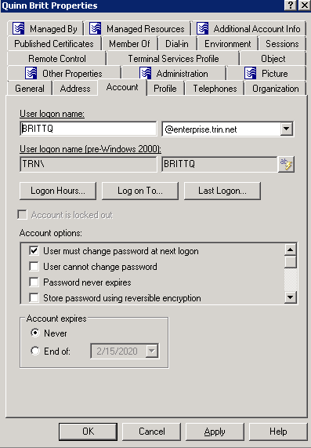

* 1. Profile tab> Check and make sure that home drive was successfully created.
  2. Telephones tab> Leave as is
  3. Organization tab > Copy and paste “Title”, “Department”, “Company” (Labeled as BU# in NHF) from new hire form and make sure the Manager's name is correct. 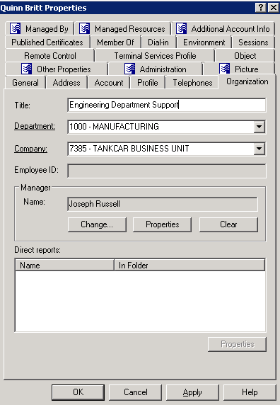

1. Look up the new user in AD and verify information is accurate and e-mail has been created automatically, if so proceed to email the requester and manager (*If user is from Mexico, only email manager) with new hire template.

EAC

Add every new user who is setup with a mailbox to the **Azure** *O365AllowGroupCreation* security group. This step grants them permission to create O365 groups.

Log in to your EAC Account and search for the new user with Login ID:  
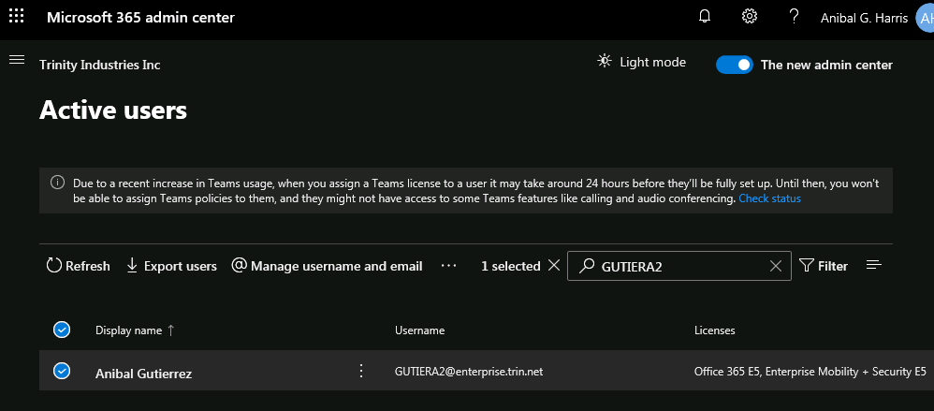

Click on Manage Groups:  
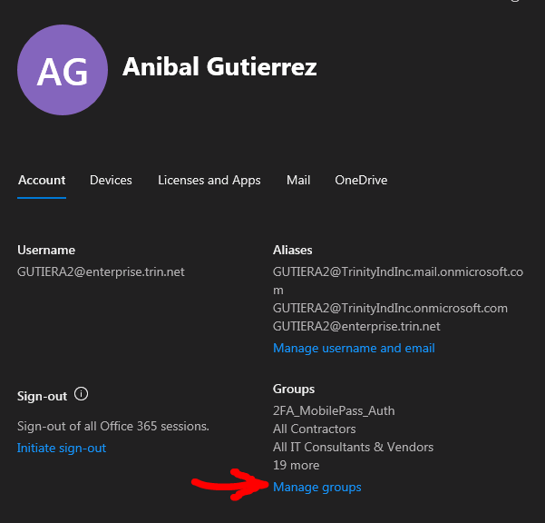

Add memberships:  
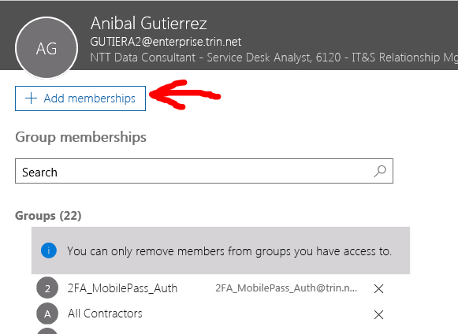

Search for *O365AllowGroupCreation* and add it to the profile. Remember to click “Save”.  
  
Open “Manage groups” once more to verify the group is added correctly:  
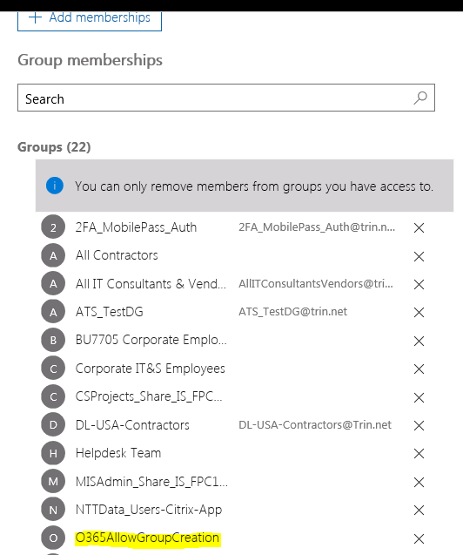

**VPN**

If New Hire Form states for VPN to be granted, then search for the user’s profile in Active Directory. In the “Member Of” tab add the group: 2FA_MobilePass_Auth

Check for a tsk to provide Mobilepass token, if such exists, the user will need the group that provides access with token (2FA_EToken_Auth).

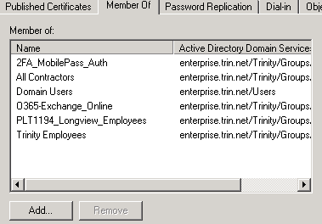

**NOTE:** All NTT contractors must be added to 2fa_MobilePass_CitrixAuth:  
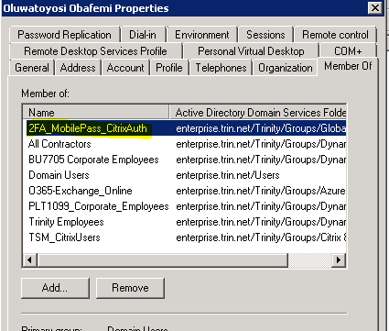

**USERS WITHOUT EMAIL**

1. Create the account under the “TRN Provision w/o Mailbox > Users”
2. Third party e-mail should be provided by the requestor. Search in notes or attachments in TSM. If the email was not found, contact the requester to obtain it.
3. Once the third party email was obtained go to Active Directory “General” tab and add the email in the email box and then add the VPN group as stated above.

**NTTDATA NEW HIRES**

The staging process remains almost the same, just make sure you follow the next additional steps:

1. Create the account under the “TRN Provision w/o Mailbox > Users” (uncheck the create email box during staging).

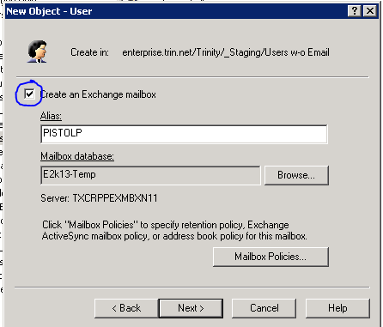

1. Since we already include the VPN in our staging process, we will need to complete the secondary task created after the “New Hire – NTT Data Employee AD Account –“



New Hire Template

After Active Directory account is created a notification email is sent to user’s manager with New hire information.

Hello *Requester’s Name*,

Below is the login information for *User's Name*

Username: **

Temp Password: **

Employee#: **

Email: **

Account Expires: Never

If the user is working remotely, please have them log in to [www.owa.trin.net](http://www.owa.trin.net). They will be prompted to change their password and then they may setup the VPN.

Regards,

(Signature)

**New Hire Task closing notes**

AD, VPN, and Email account have been created for the new user; the login information has been emailed to requester and manager.